  Name: | ___________________________________________________ |  |  | Date: ___________
 | Year 11 Applications  Test 2, 2016  Topics – Other Financial Considerations and Pythagoras’ Theorem |  |  | 52  = %
Total Time: | 50 minutes
Total Reading: | 5 minutes
Total Working: | 45 minutes
Weighting: | 4% of the year,8% of the semester.
Equipment: | SCSA Formula Sheet; 1 page notes (A4 one side, Unfolded), CASIO ClassPad; Scientific Calculator
SECTION 1: CALCULATOR FREE
Time: | 17 minutes | Marks for Section 1: | 15
Reading: | 2 minutes | Equipment Allowed: | Nil
Working: | 15 minutes

1. | [3 marks]
 | A section of a spreadsheet, provided below, shows the number of hours worked by three students during the course of a week. The students are paid time and a half on Saturdays and double time on Sundays.
 | A | B | C | D | E | F
1 | Name | Rate  ($/hour) | Weekday hours | Saturday hours | Sunday hours | Total pay
2 | Gen | 20 | 5 | 6 | 3.5
3 | Bri | 22.5 | 10 | 3 | 3
4 | Ala | 23.68 | 8 | 4 | 6

a) | How much will Gen earn in a week?
2. | [1 mark]
 | Which equation below is correct for triangle XYZ according to Pythagoras’ theorem?
 | 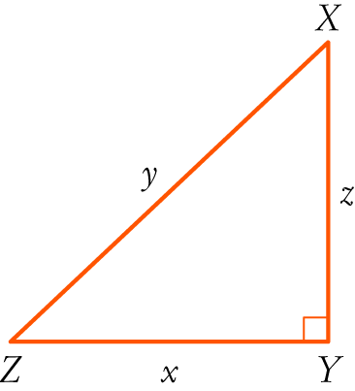 | A x² = y² + z²  B y² = x² − z²  C y² = x² + z²  D x² = z² + y²  E z² = x² + y²
3. | [3 marks: 1, 1, 1]
Cereal is available in the following packs:
300g for $6.00 and 150g for $4.50

Determine:

a) | The cost per gram of the larger box.
b) | The cost per gram of the smaller box.
c) | Which of the two packs is the better value?

4. | [2 marks]
 | Determine whether the following triangle is a right angle triangle and give mathematical reasons for your conclusion.
 | 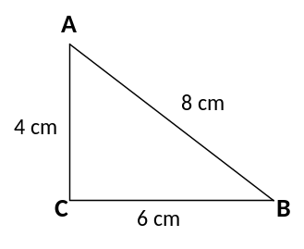
5. | [1 mark]
 | Determine the price to earnings ratio for a share with a price of $6.00 and dividends in the last twelve months totalling 75 cents per share.
6. | [1 mark]
 | Andrew picks cherries and earns $2.50 per bucket. How many buckets does he need to pick to earn over $300?
7. | [4 marks: 1, 1, 1, 1]
This table shows the payment rates for people who are on the Newstart allowance. To be eligible for Newstart you must be 22 years of age or older and unemployed but looking for work.
Status | Dependents | Fortnightly allowance
Single | No | $492.60
Single | Yes | $533
Partnered |  | $444.70

For each of the following state whether they are eligible. If they are, state the amount of allowance that they receive.

a) | Kym, aged 24, is single, unemployed and without children. She is looking for work.
b) | Jake, aged 34, is married with no children. He has a part-time job and is looking for full-time work.
c) | Gregor, aged 28, is a single father who cares for his two children full-time. He is looking for work.
d) | Maxine, aged 20, is single and has one child. She is looking for work.
~ END OF TEST SECTION 1 ~
Name: | ___________________________________________________ |  |  | Date: ___________
SECTION 2: CALCULATOR ASSUMED
Time: | 33 minutes | Marks for Section 2: | 37
Reading: | 3 minutes | Equipment Allowed: | 1 page notes (A4 one side, unfolded),  CASIO ClassPad, scientific calculator
Working: | 33 minutes

8. | [8 marks: 4, 2, 2]
John wants to see which of the two banks in his portfolio of shares is the better performer, and he decides to use the P/E ratio to compare the two banks.

AAA Bank’s shares are currently $33.65 while ZZZ Bank’s shares are currently $32.055.
AAA Bank has annual earnings of 207.5 cents per share.
ZZZ Bank has annual earnings of 223.1 cents per share.

a) | Calculate the P/E ratio for each bank and make a recommendation as to which bank John should buy more of, if the P/E ratio was the only indicator to be used. Justify your recommendation.
Dividends from both banks are paid twice a year and in the last year AAA Bank gave dividends at
82c and 84c per share.

b) | What percentage of its annual earnings does AAA Bank distribute to shareholders?
c) | ZZZ Bank paid an interim dividend of 66c per share. It has a policy of paying 65% of its annual earnings as dividends. What would you expect its final dividend payout to be?
9. | [3 marks]
Chocolate Easter eggs are on special at a local supermarket.
The larger eggs (110g each) are advertised at ‘Two for $4’ and the smaller ones (39g) cost $1 each. By calculating the cost per gram of chocolate, determine which size represents better value for money.

10. | [5 marks: 1, 1, 3]
Shizuko is setting up her weekly budget.

Shizuko’s weekly budget
Income |  | Expenses
wage | $ | rent & power | $360
 |  | food | $135
 |  | fares | $78
 |  | phone | $
 |  | clothes | $120
 |  | gifts | $35
 |  | entertainment | $150
 |  | savings | $
Total: | $ | Total: | $

a) | She earns $27.50 per hour for a 37-hour work week. What is her weekly wage?
c) | Her mobile phone plan costs her $99 a month. How much should she budget each week to cover this?
d) | She hopes to save enough to pay for a $7000 cruise in one year’s time. Will she be able to save enough if she sticks to this budget? If not, what would you suggest she do to save more?
11. | [5 marks: 1, 1, 1, 2]
Answer the following questions using the exchange rate table below.

Rates Converter for 1.00 Australian Dollar
Mar 16, 2016 10:57 UTC
Australian Dollar | 1.00 AUD
US Dollar | 0.745558
Euro | 0.672506
British Pound | 0.528228
Indian Rupee | 50.142830
Canadian Dollar | 0.996065
Singapore Dollar | 1.029413
Swiss Franc | 0.737082
Malaysian Ringgit | 3.091306
Japanese Yen | 84.705852
Chinese Yuan Renminbi | 4.862035

a) | What is $1 Australian dollar worth in US Dollars?
b) | What is $1 Singapore Dollar worth in Aus $?
c) | Ammaarah is going overseas on a holiday and wants to exchange $550 Australian into British currency. How much money will she have in British pounds?
d) | Chloe has just arrived home from a holiday in Canada. She had $25 left in Canadian dollars. They charge $5 to exchange money at the local Cash Exchange office. How much money will she end up with after the exchange?
12. | [2 marks]
 | Firemen have a 10m ladder and they are unable to get closer than 5m from the base of a building due to obstructions. Will the ladder be long enough to reach a window that is 8.5m high? (Show all working)
 | 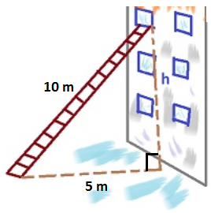
13. | [1 mark]
 | Dayna picks apples to earn some extra cash during her holidays. If Dayna is paid at a rate of 25 cents per kg of apples she picks, how much will she earn if she has picked 120.5kg?
14. | [2 marks: 1, 1]
a) | Shanaya’s take home salary after tax is $45 850 p.a. If she gets paid fortnightly, how much is her fortnight pay?
b) | Defence personnel living away from their families receive a yearly family separation allowance of $2 560. If a Defence member earns a salary of $95 000 and they qualify for the separation allowance, what would be their weekly pay?
15. | [7 marks: 3, 1, 3]
 | Paula bought 5500 shares in Qantas Air at $2.47 per share, with 1.7% brokerage (added to the cost).
a) | Calculate the total cost of buying her shares.
b) | If the company pays a dividend of 14c per share, calculate Paula’s dividend.
c) | Paula sells her shares one year later when the market price of the shares is $2.80. She paid 1.7% brokerage. Calculate her total earnings on the shares, after costs.
16. | [4 marks]
The diagram shows a cube of side 5cm. Find the length of AB.
Hint: You will need to use Pythagoras’ Theorem twice – find one side and then use it to find AB.
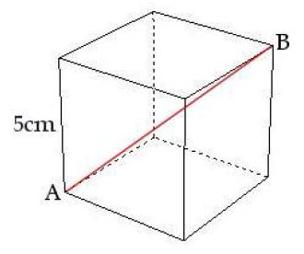

~ END OF TEST SECTION 2 ~

